# VGG Paper

Visual Geometry Group

Main Contribution :

* (3x3) convolution filters
* 16-19 weight layers

What do we see in this paper ?

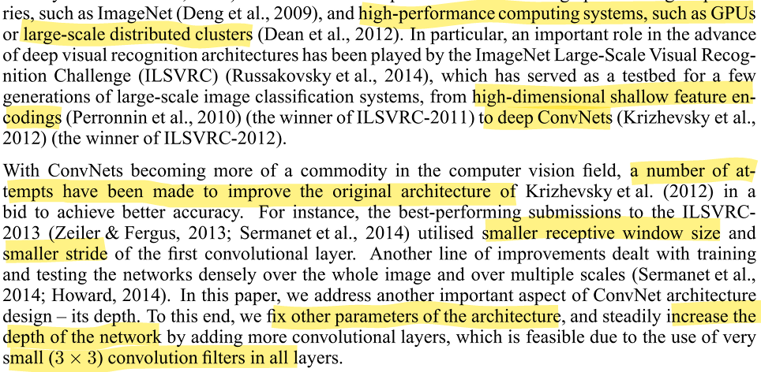

Architecture :

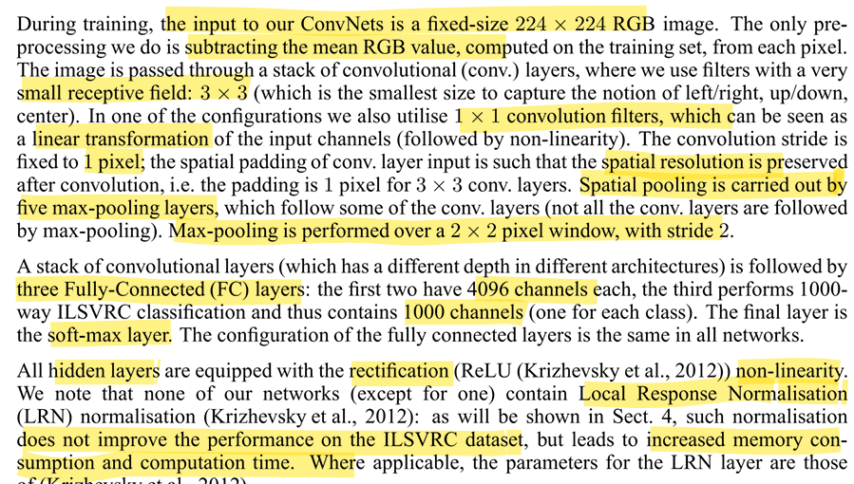

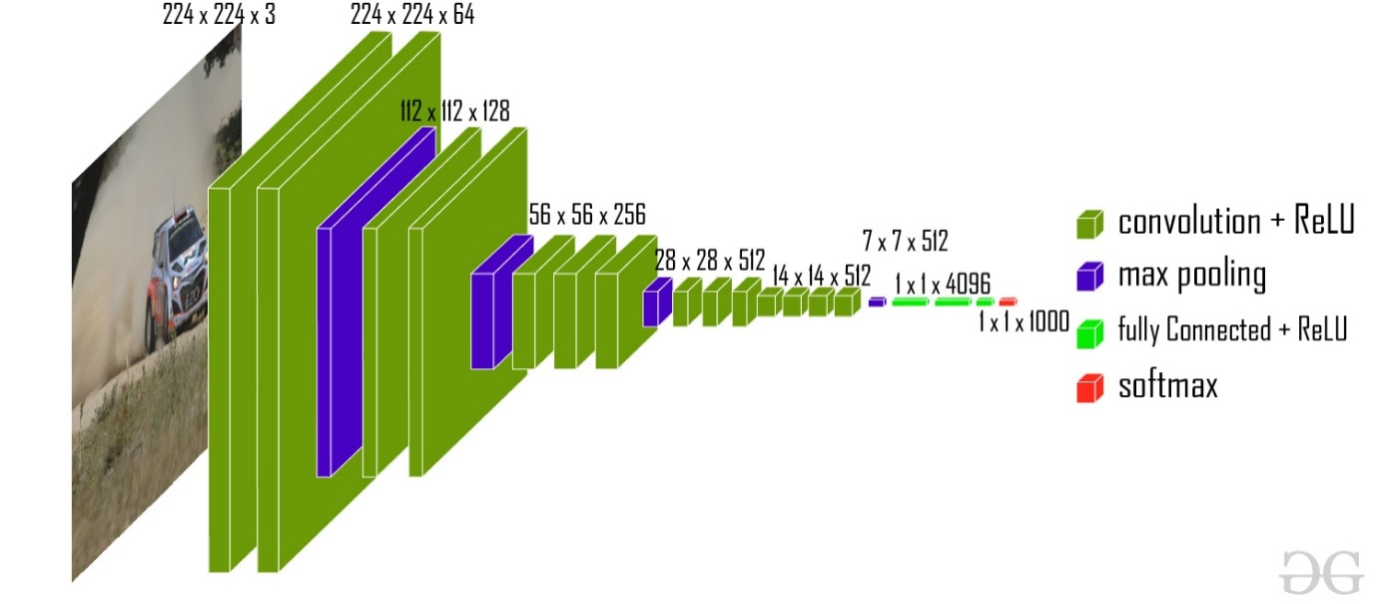

16 weight layers model

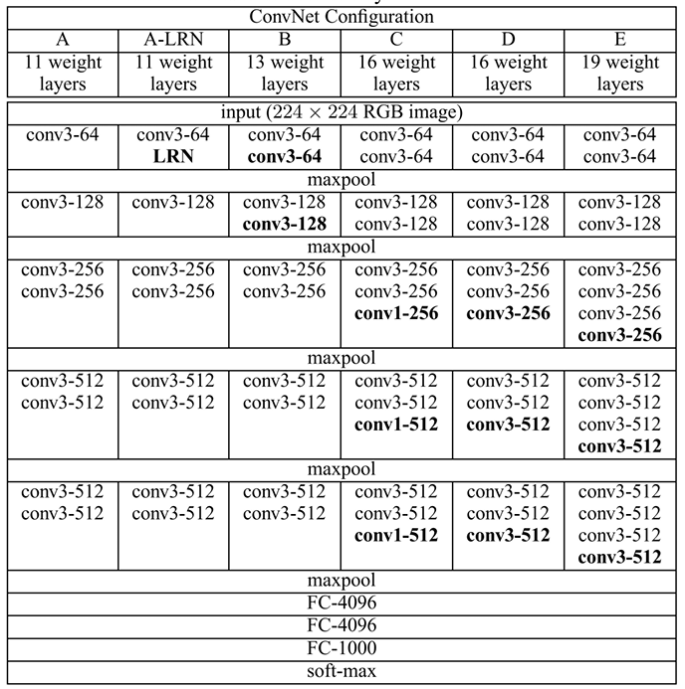

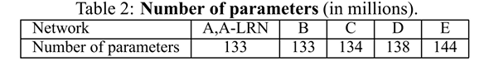

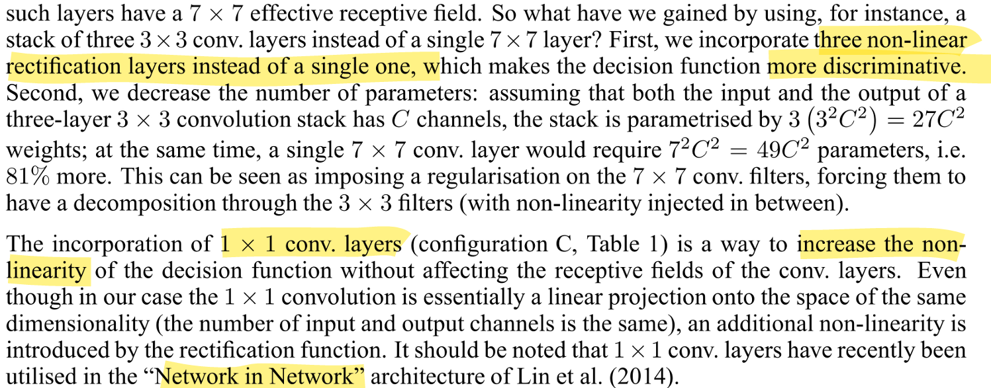

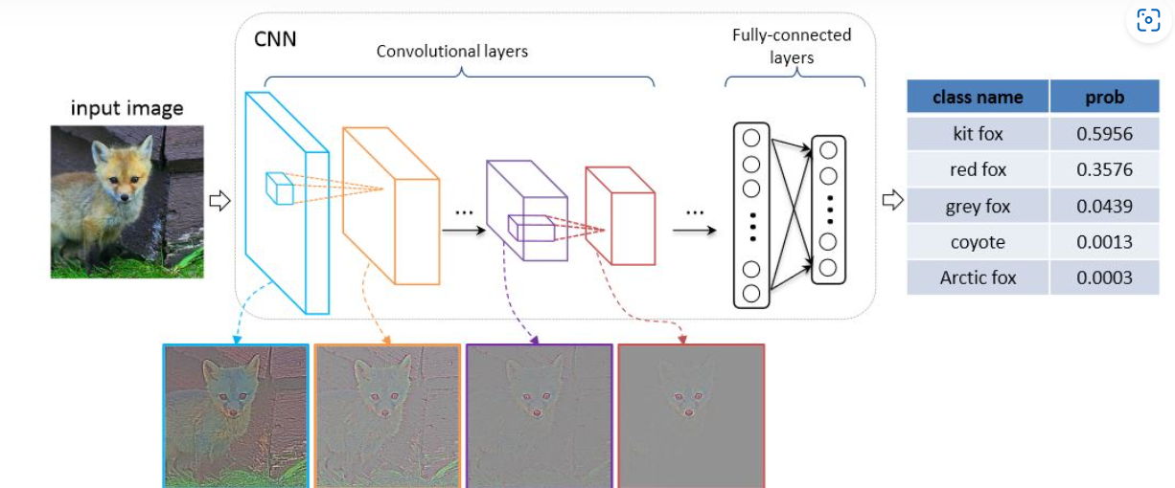

How did the data get trained ?

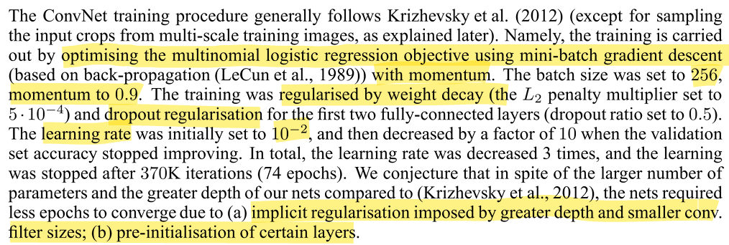

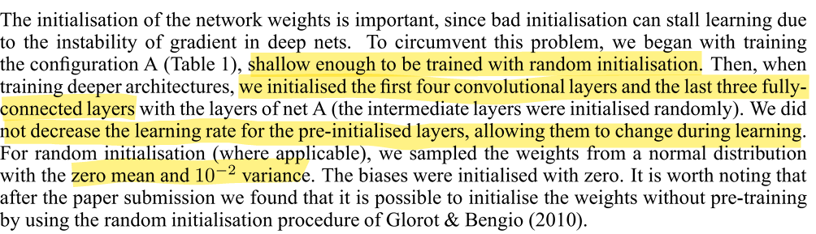

Training Image Size :  
Let S be the smallest side of an isotropically-rescaled training image

There are two approaches for training the images

1.

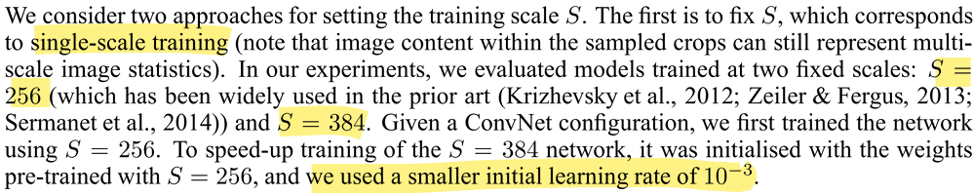

2.

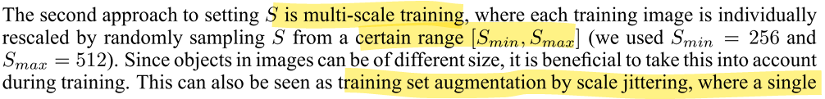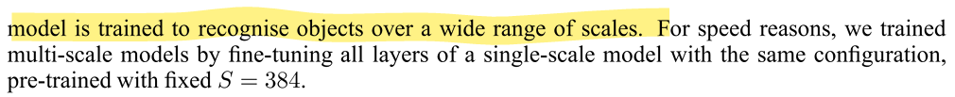

Training :

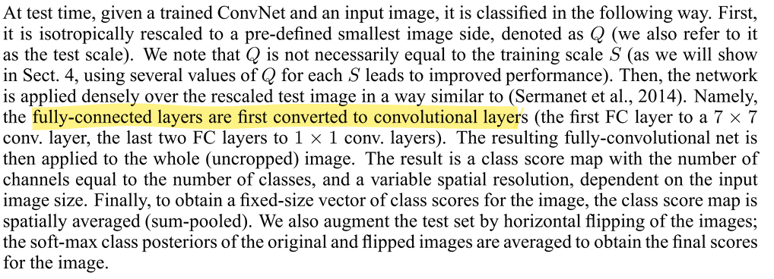

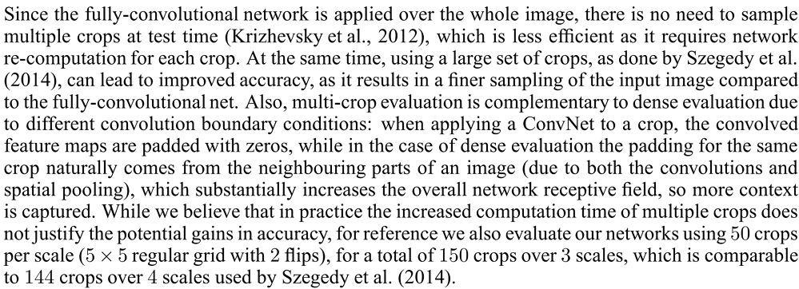

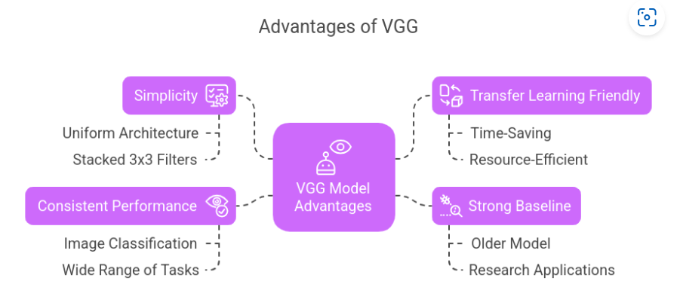

Implementation :

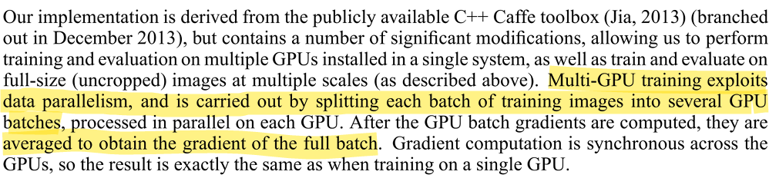

Classification Experiments :

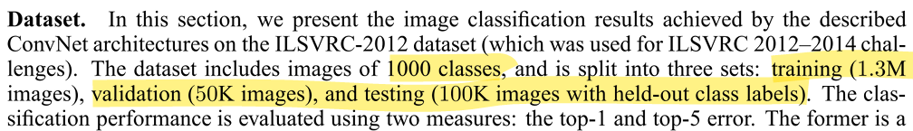

Single Scale Evaluation :

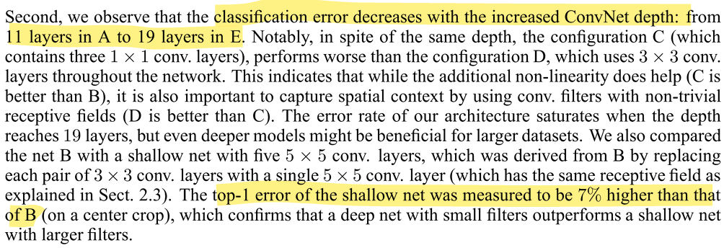

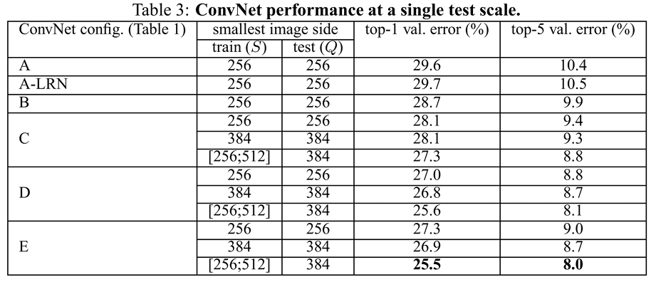

Multi-Scale Evaluation :

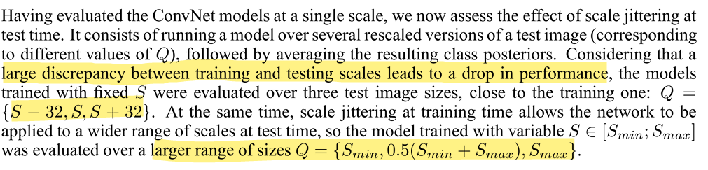



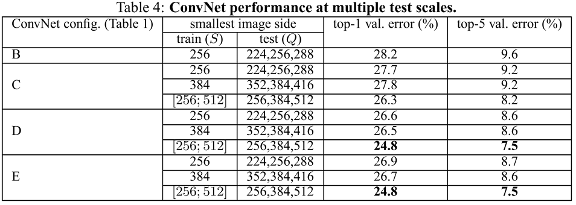

Multi-Crop Evaluation :



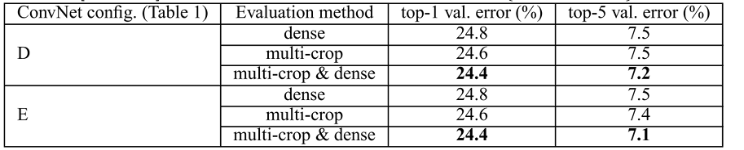

ConvNet fusion :

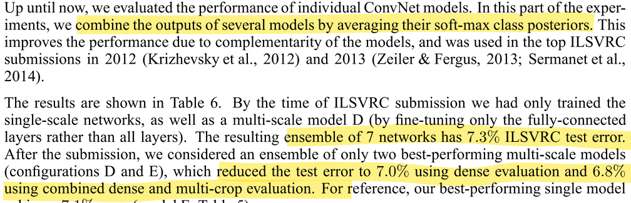

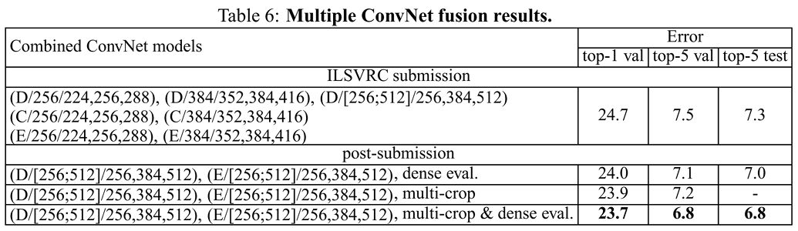

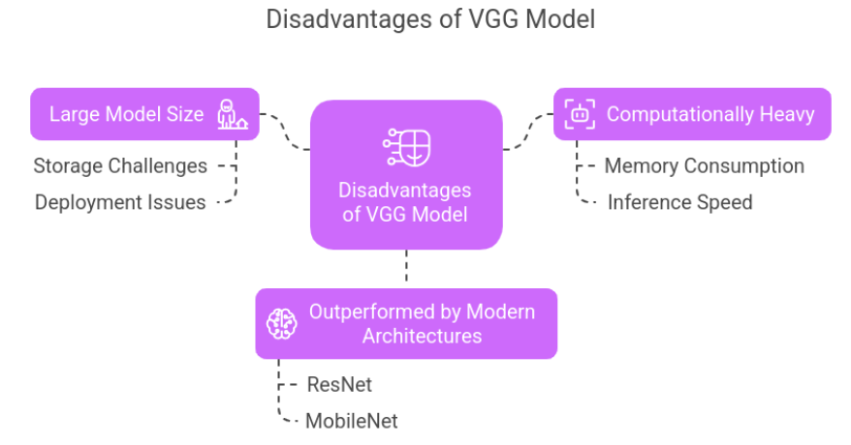

Localization :

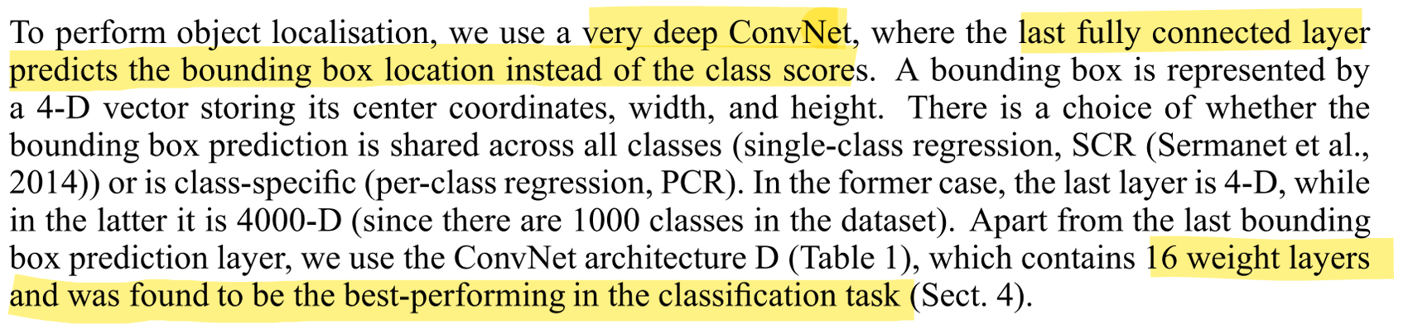

Training :

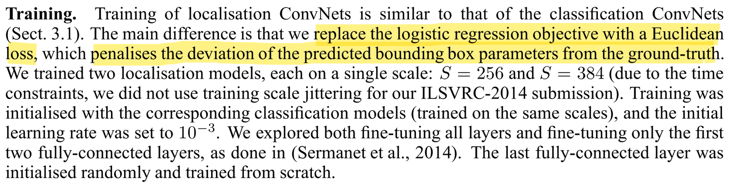

Testing :

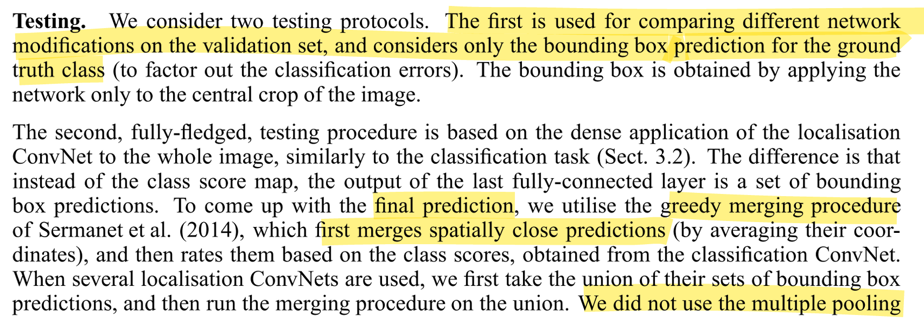

Localization Experiments :

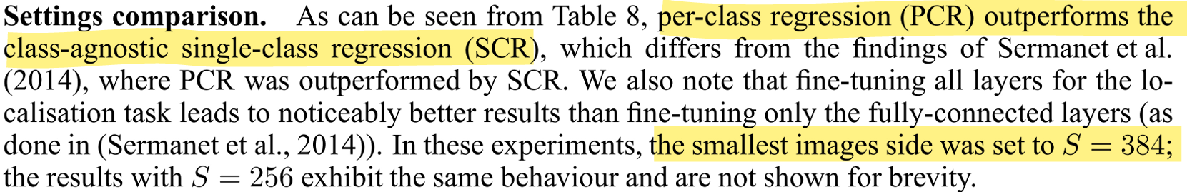

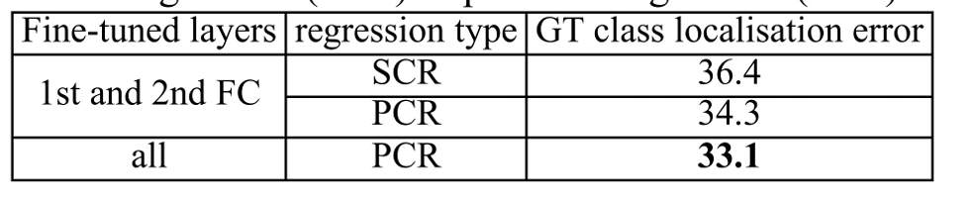

Comparison with the state of art in ILSVRC localization :

